Pass for level 13: jmLTY0qiPZBbaKc9341cqPQZBJv7MQbY

Step 1: Entering to natas 12

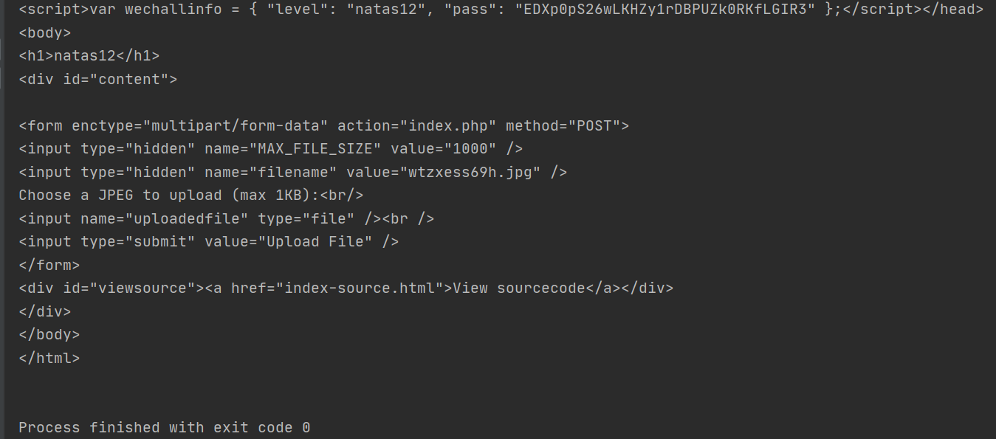

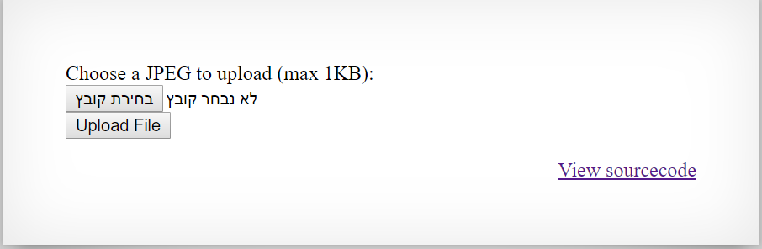

Step 2: Using post request via python program by instruction follows image number 1.

Named : Level12.py

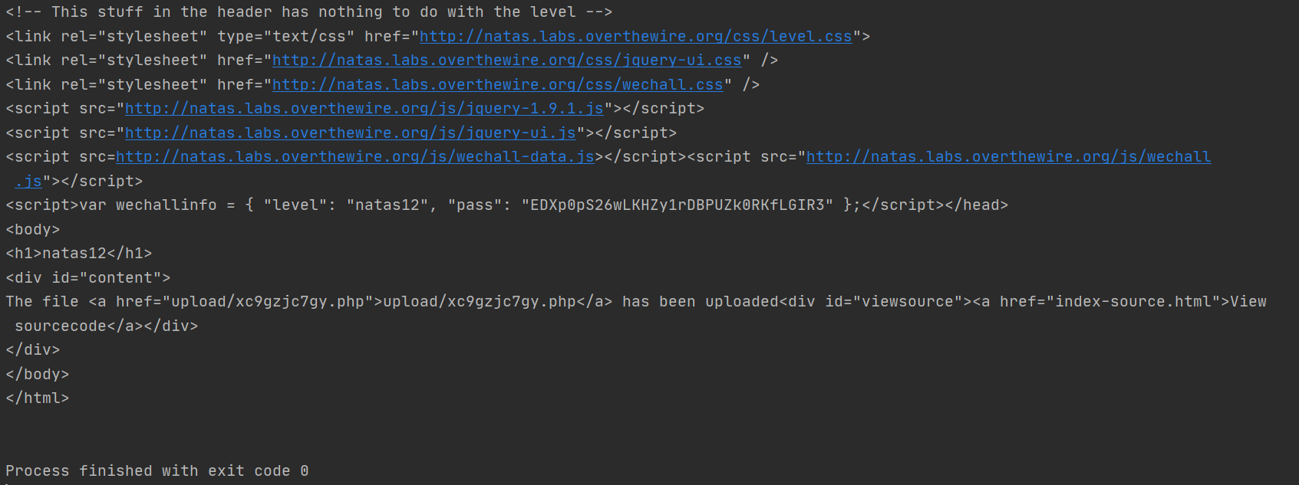

Step 3: Search for get request for the extension upload/xc9gzjc7gy.php

